Pass for level 18: xvKIqDjy4OPv7wCRgDlmj0pFsCsDjhdP

Step 1:Login

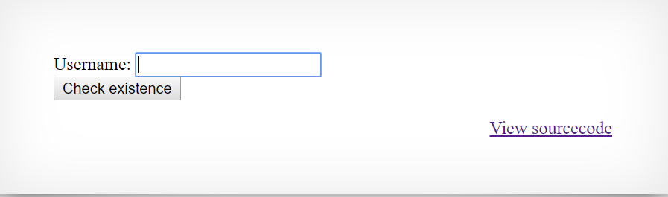

Its look familiar and it could be anything so..

Step 2: View source code

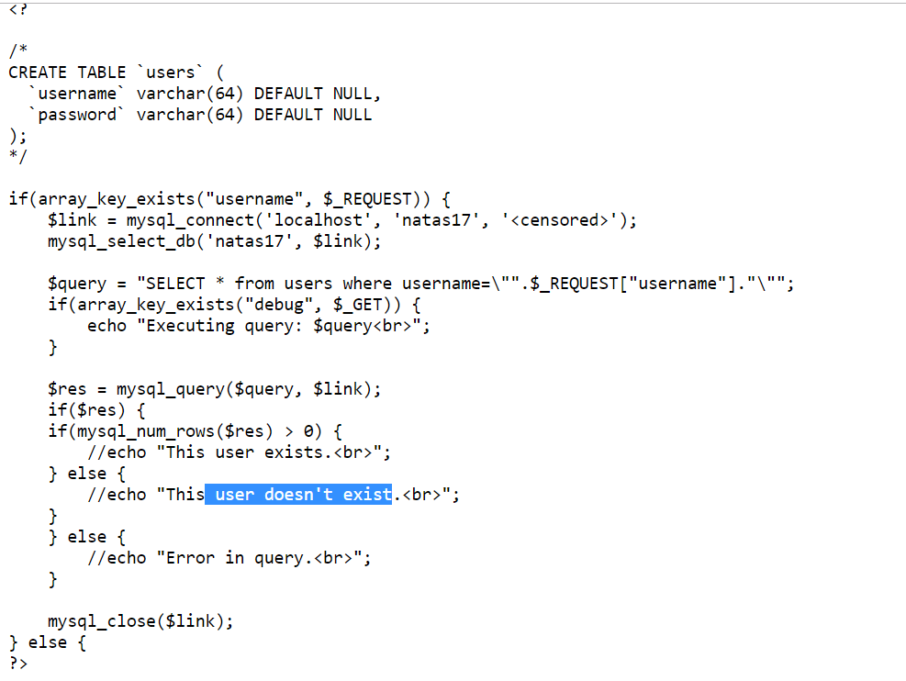

Now in contrast to previous levels we don’t have any text feedback from server side to our inputs.

May be we need to dig deeper in SQL commands to see some reactions

Step 3: We can execute some commands in SQL query like **SLEEP()** command

We will execute program that post: "SELECT * from users where username = **"natas18" AND password LIKE BINARY <brute-force>% AND SLEEP(3)**

It will actually sleep 3 seconds and I can determine that in the program.

